Lab 1 - Chat with Your Data using Fabric Data Agent

Platform
• Microsoft Fabric portal
• Published Fabric data agent
• Supported Fabric data source

Architecture
Fabric data source
↓
Fabric Data Agent
↓
Published Agent

PART 1 — PARTICIPANT EXECUTION

Step 1 — Open Microsoft Fabric and confirm prerequisites
1. Open Microsoft Fabric and sign in with the assigned organizational account.
2. Open the workspace supplied for the lab. Do not create a new workspace unless the lab administrator explicitly instructs you to.
3. Confirm that the workspace contains a supported data source and that you have at least read access to it.
4. Confirm that the Fabric data agent capability is available in the tenant and that the workspace is on a supported capacity.

Validation
1. The assigned Fabric workspace opens successfully.
2. A supported data source is visible and can be read by your account.
Microsoft Learn: https://learn.microsoft.com/en-us/fabric/data-science/how-to-create-data-agent
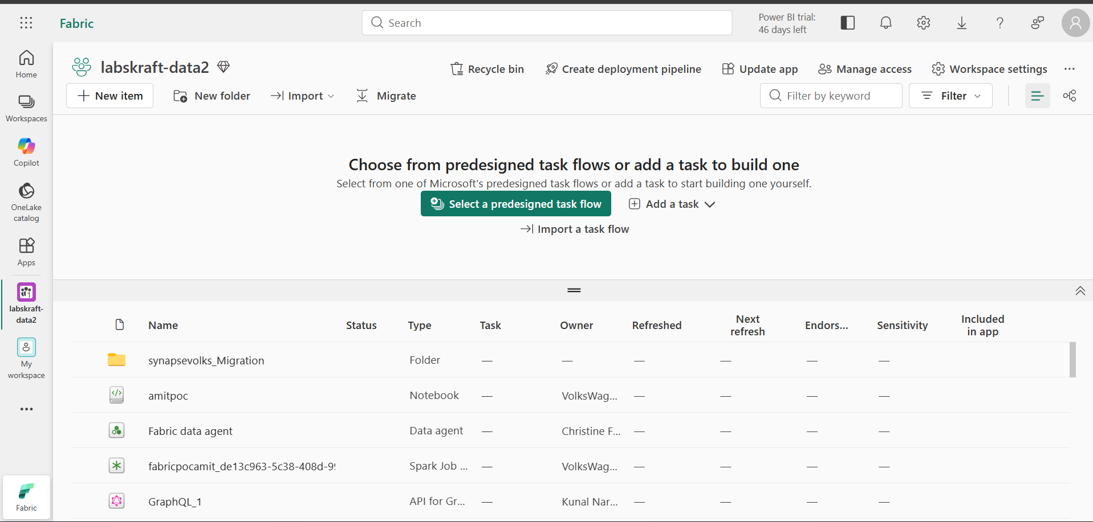

Step 2 — Create the Fabric Data Agent
1. Inside the assigned workspace, select + New item.
2. Search for Fabric data agent and open the Fabric data agent item.
3. Give the agent a clear name such as Enterprise Data Chat Agent.
4. Create the agent and wait for the configuration experience to load.

Validation
1. The new Fabric data agent opens in its configuration experience.
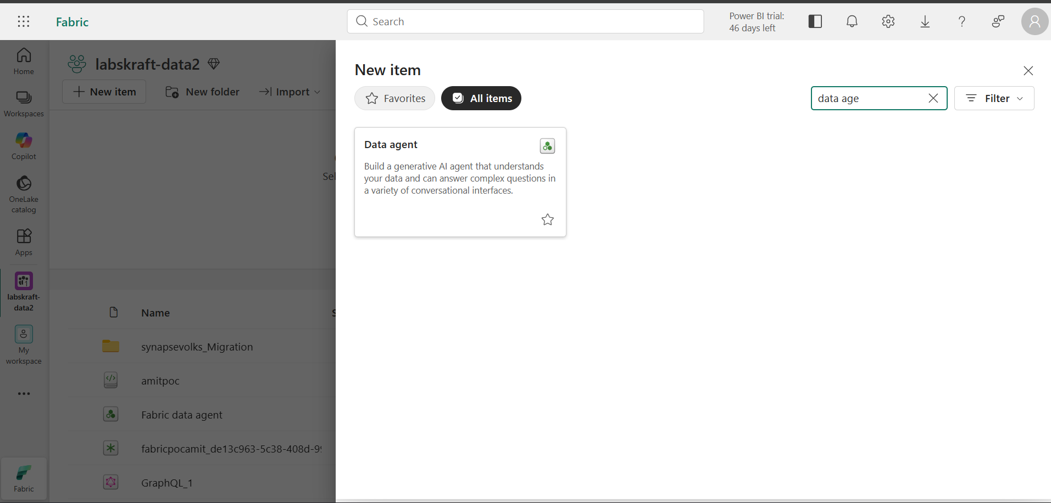
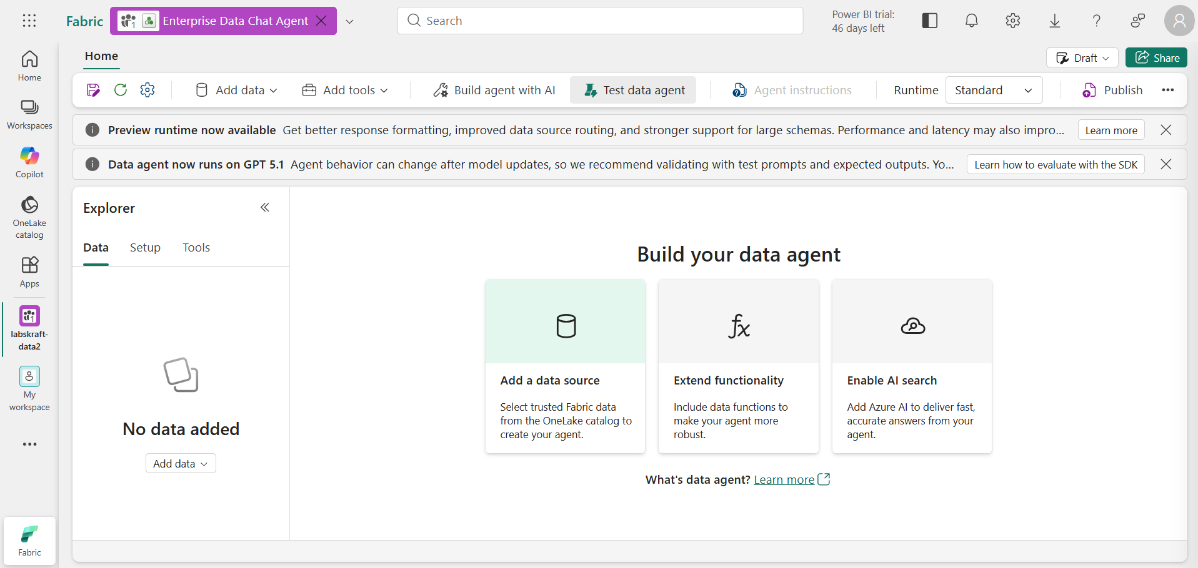

Step 3 — Add the Enterprise Data Source
1. At the top of the Microsoft Fabric page, select the Enterprise Data Chat Agent tab to return to your Fabric Data Agent.
2. In the Data Agent configuration page, locate the section for adding data sources and select Add data source.
3. From the available source types, select Lakehouse because we created a Lakehouse for this lab.
4. In the Lakehouse selection window, locate and select:
Enterprise_Data_Lakehouse
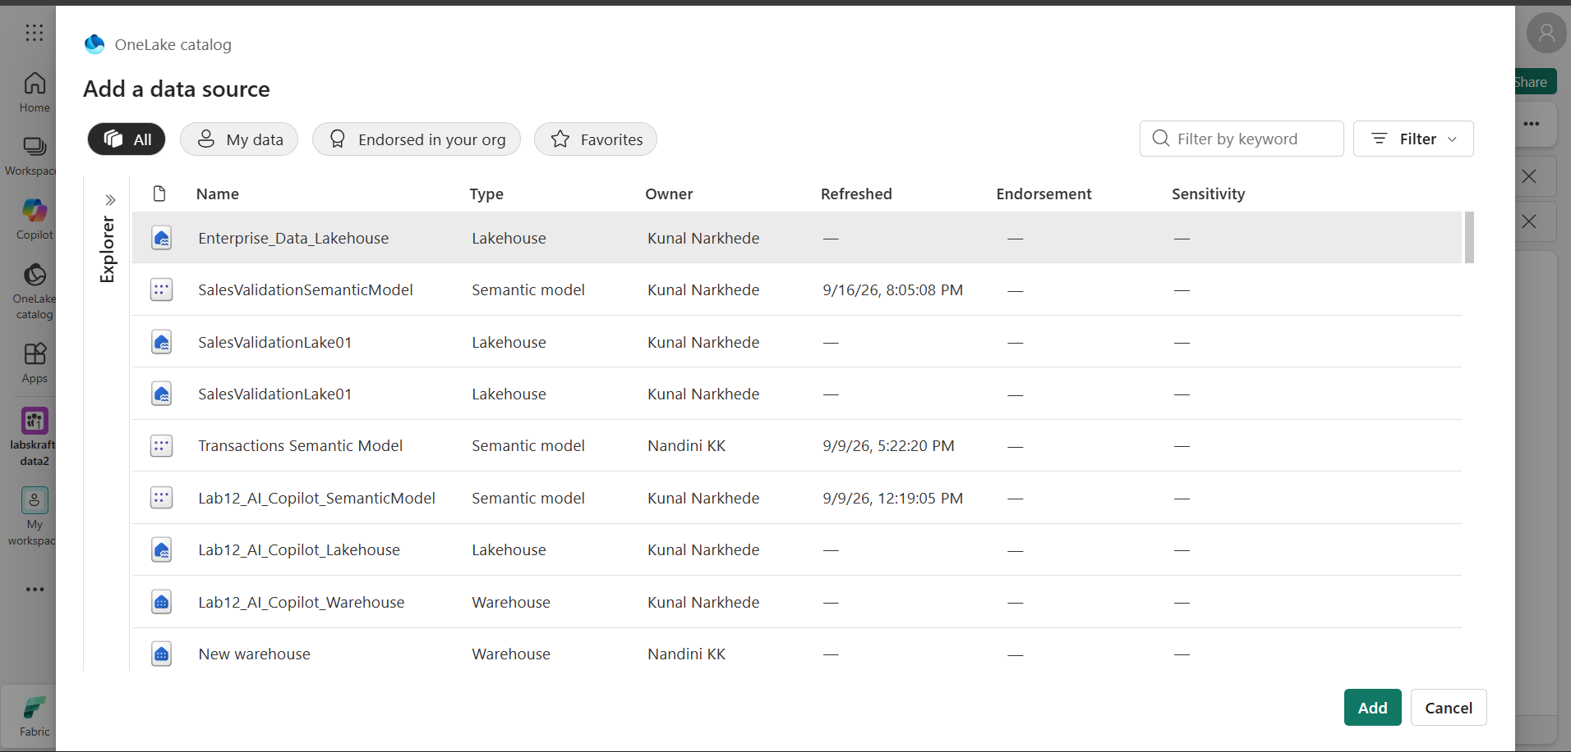
5. Select Connect or Add to connect the Lakehouse to the Data Agent.
6. After the Lakehouse is connected, locate the available tables or data elements.
7. Select only the table created for this lab:
dbo.EnterpriseSales
8. Confirm the table selection and add it to the Data Agent.
9. Wait for Fabric to finish adding the data source and loading the table schema.
10. Review the connected data source and confirm that the EnterpriseSales table and its columns are visible.
11. Save or apply the data-source configuration if Fabric displays a Save, Apply, or similar option.
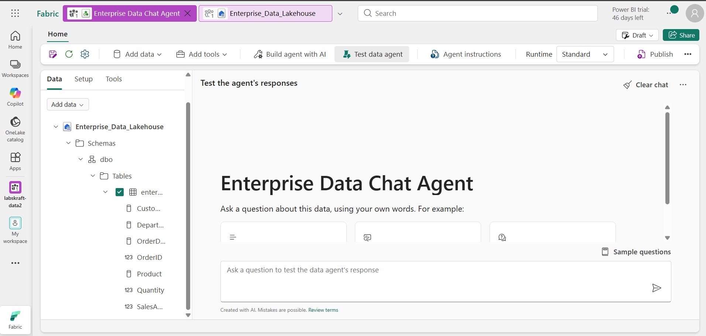

Validation
1. The Data Agent shows Enterprise_Data_Lakehouse as a connected data source.
2. The dbo.EnterpriseSales table is listed under the connected Lakehouse.
3. The table schema/columns, such as OrderID, CustomerName, Product, Department, Quantity, SalesAmount, and OrderDate, are visible and available for the Data Agent to use.
4. The data source is ready for questions in the Data Agent.

Step 4 — Configure agent instructions
You are an enterprise data assistant.
Use only the connected Fabric data source for data-specific answers.
Answer with grounded information from the available data.
Do not invent tables, columns, measures, records, dates, or values.
If the requested information is unavailable, say that it is unavailable.
For numerical questions, use the connected data rather than estimating.
Use the following instruction text in the agent instructions area:
1. Open the agent instructions area.
2. Enter instructions that define the business domain, supported questions, and grounding behavior.
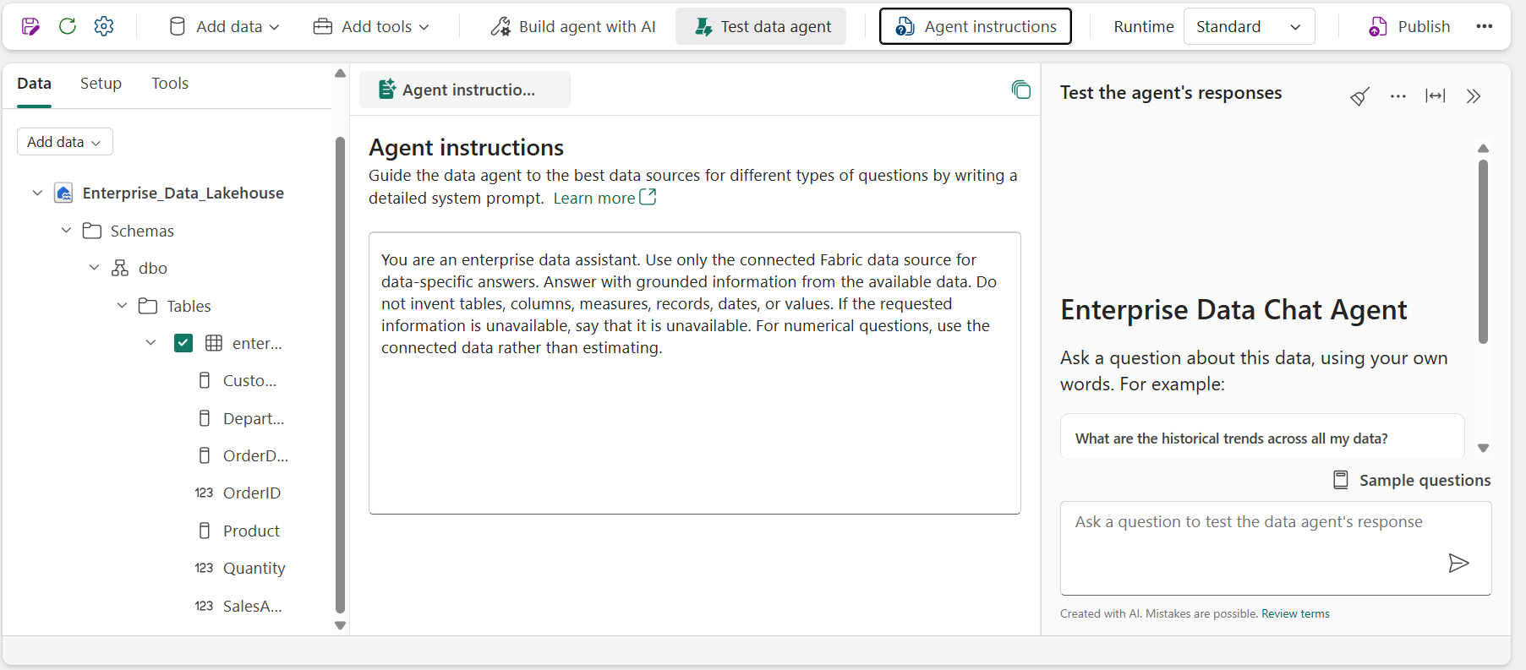

Validation
1. The instructions are saved and visible in the agent configuration.
2. The instructions clearly tell the agent to use the connected Fabric data and not invent unavailable values.

PART 2 — CHAT WITH FABRIC DATA

Step 5 — Add Business-Grounded Example Questions
1. Open the Agent instructions / configuration area where example or sample questions can be added.
2. Add the following aggregate question:
What is the total sales amount?
This uses the SalesAmount field.
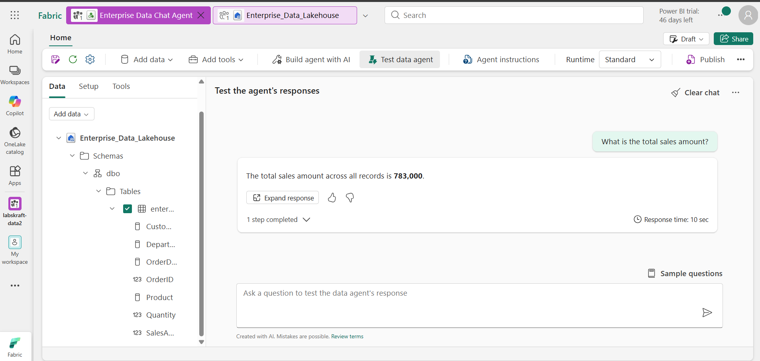
3. Add the following filter question:
What are the total sales for the Technology department?
This uses Department and SalesAmount.
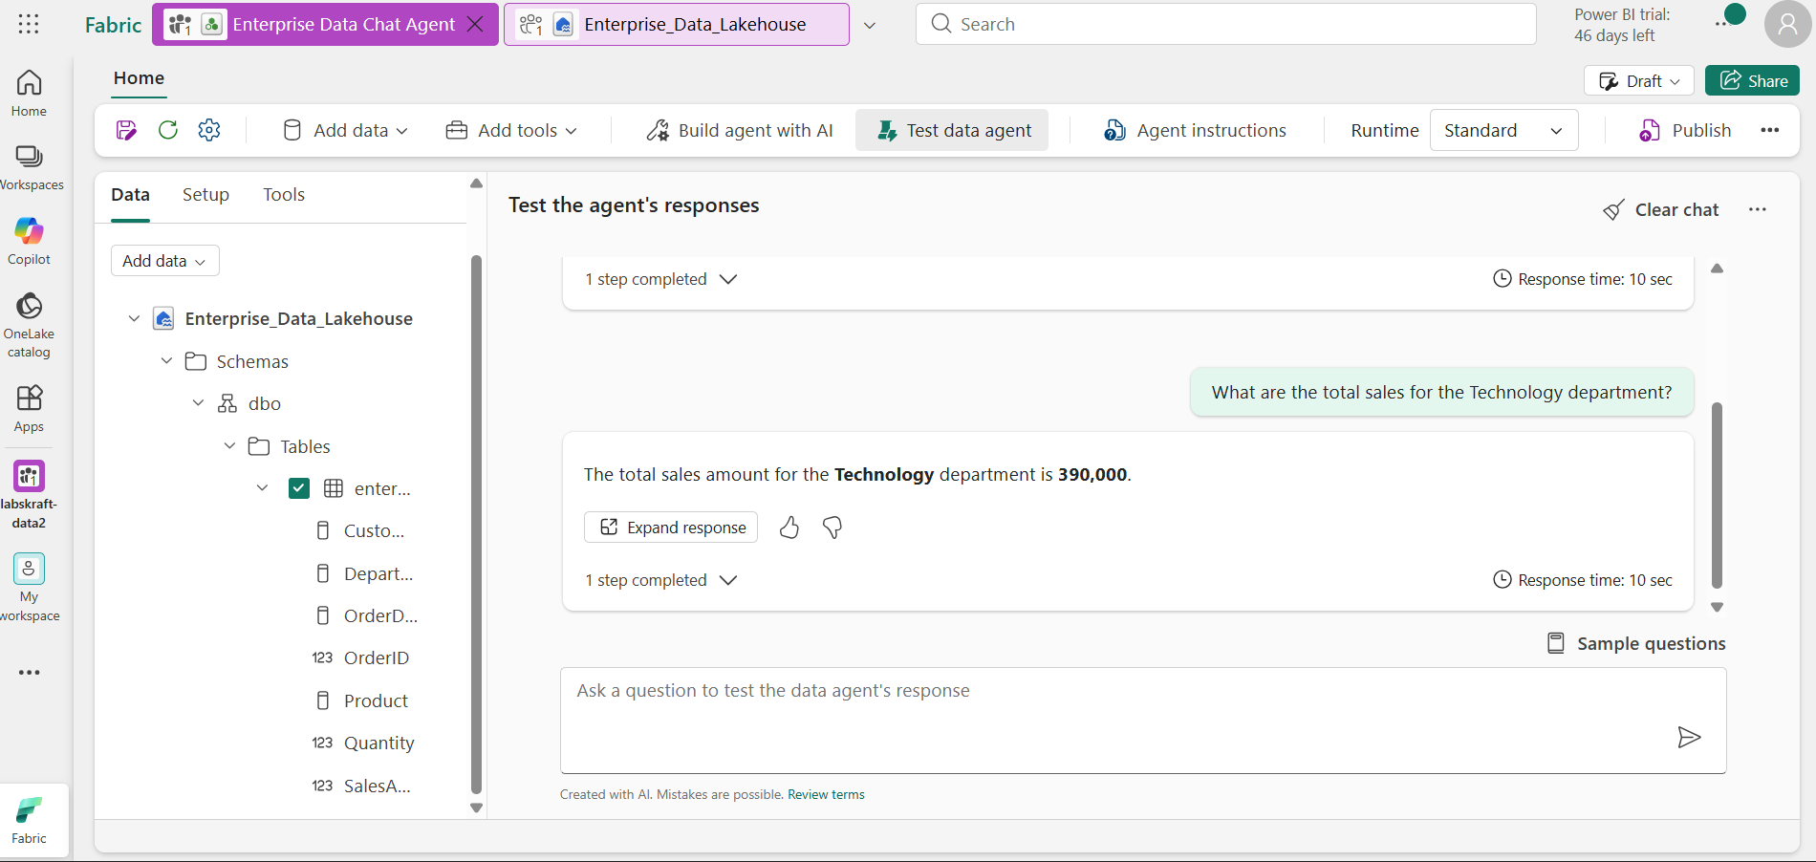
4. Add the following detail question:
What product did Priya Patel purchase?
This uses CustomerName and Product.
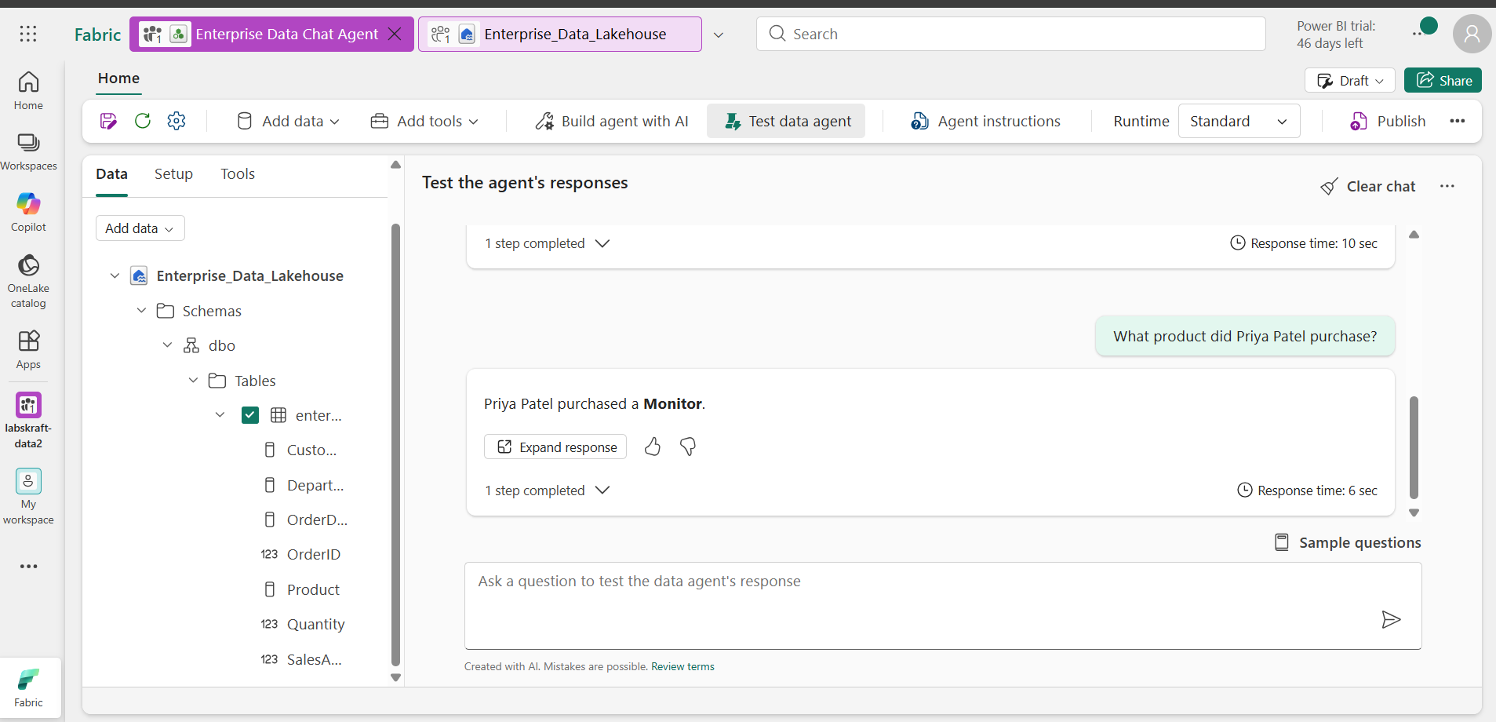
5. You can also add this additional question if the interface allows more examples:
How many laptops were sold?
This uses Product and Quantity.
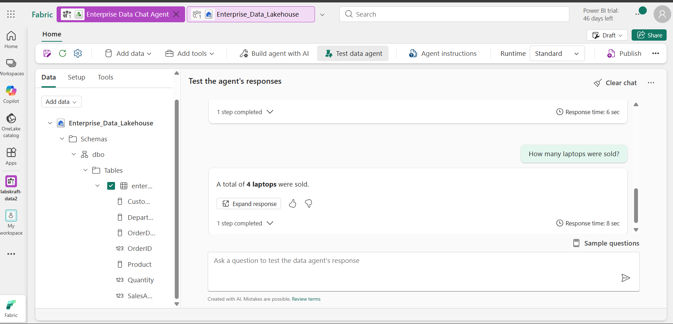
6. Review the questions and make sure they refer only to fields that exist in EnterpriseSales.
7. Save or apply the example questions.

Step 6 — Test the Fabric Data Agent

1. Open the test experience
In your Enterprise Data Chat Agent, select:
Test data agent
You should see the Test the agent's responses chat area.

2. Ask a simple data-backed question
In the question box, enter:
What is the total sales amount?
For our dataset, the expected result is:
₹797,000
The agent should calculate this from the SalesAmount column rather than making an estimate.
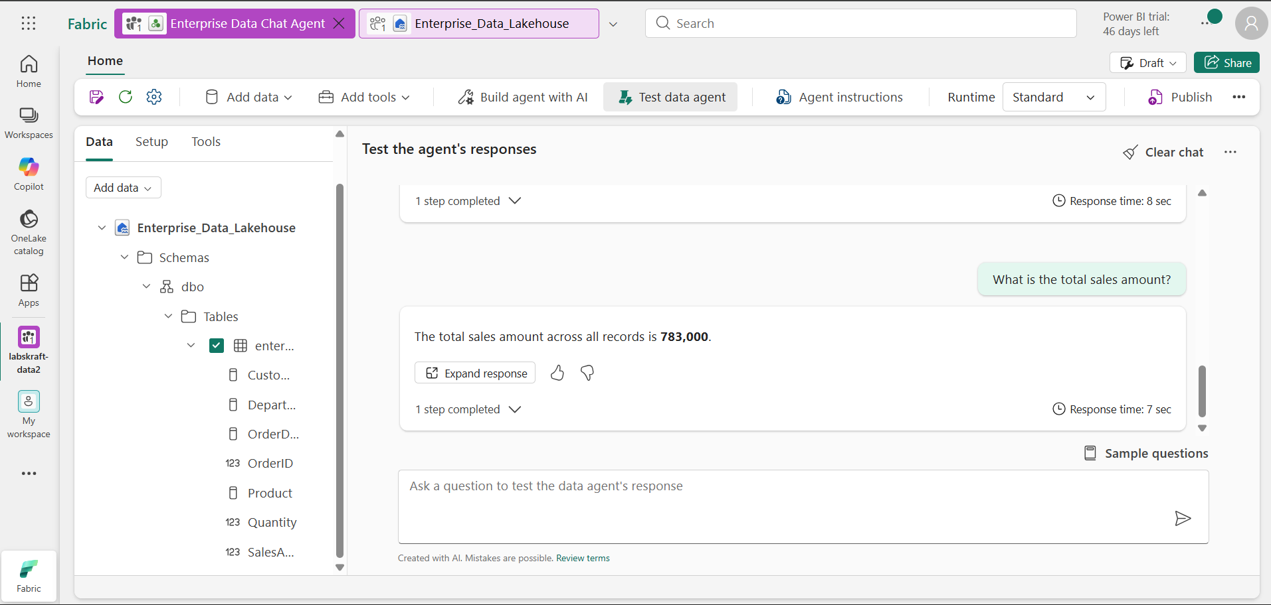

3. Ask a filtered question
Now enter:
What are the total sales for the Technology department?
Expected result:
₹300,000
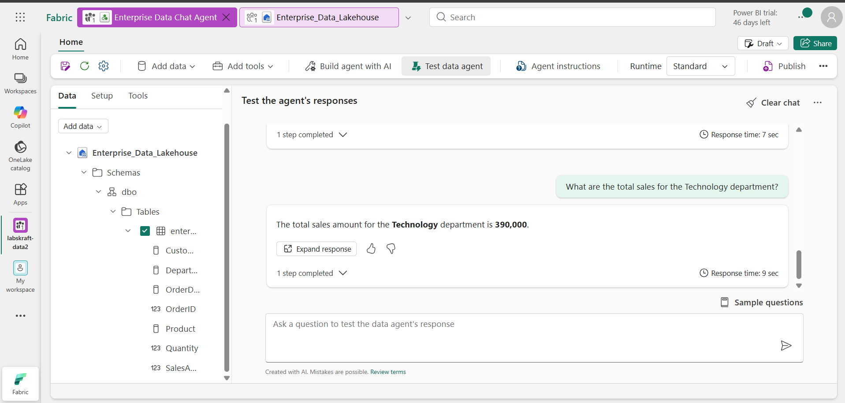
This tests both:
- Department
- SalesAmount

4. Review the response
Check whether the agent:
- Uses the EnterpriseSales table.
- Returns a data-backed answer.
- Correctly applies the requested filter.
- Does not introduce information that isn't present in the dataset.
- Shows a generated query, source information, or grounding details if your current Fabric experience exposes them.

Step 7 — Publish the Fabric Data Agent

1. Open the publishing controls
In your Enterprise Data Chat Agent, look at the top-right area of the page.
Select Publish.

2. Add/review the publishing description
If Fabric displays a description field, use this beginner-friendly description:
Enterprise Data Chat Agent provides grounded answers about enterprise sales data, including orders, customers, products, departments, quantities, sales amounts, and order dates.
This clearly identifies the data domain and the types of questions the agent can answer.
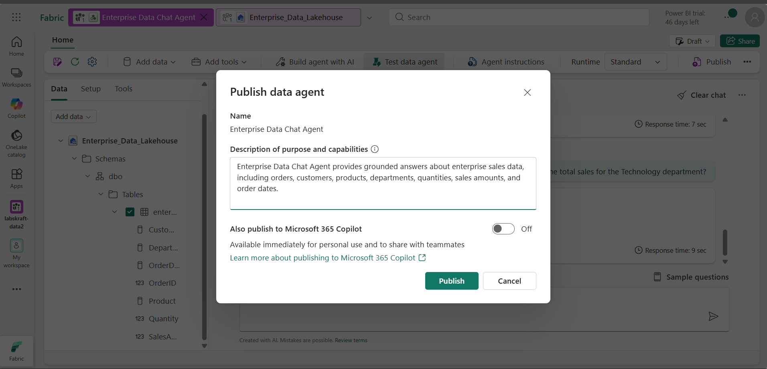

3. Publish the agent
Review the publishing information and select Publish.
If Fabric asks you to confirm the publishing action, confirm it.

4. Wait for the published state
Wait until Fabric finishes publishing.
The agent should no longer be shown only as a draft. The published state/status should be visible in the interface.
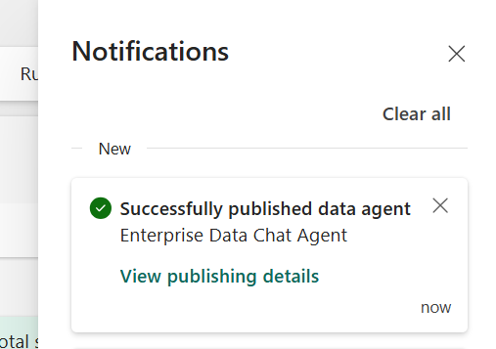

Final Validation Checklist
1. The Adventure Works sales dataset is uploaded to the Fabric Lakehouse and the required table is created successfully.
2. The Fabric Data Agent is created and connected to the Adventure Works sales data.
3. The required agent instructions are configured to ensure responses are grounded in the connected Fabric data.
4. Business-grounded example questions are configured using the available sales fields.
5. The Fabric Data Agent successfully answers a basic sales question using the connected data.
6. The Fabric Data Agent successfully answers a filtered sales question using a valid business field.
7. The Fabric Data Agent successfully answers a detail-level question using the available sales records.
8. The Fabric Data Agent is published successfully.
9. The published agent provides data-grounded sales answers without inventing unavailable values.
10. The lab objective is completed: a working Adventure Works Sales Analytics Fabric Data Agent is available for business users to ask sales-related questions.

Lab Completion
The lab is complete when all validation checks pass and the published agent returns grounded answers from the configured Fabric data source.

